**Question No: 01**

**(a) Define multimedia system. What are the desirable features of a multimedia system? 2.5**

**Ans:**

**Multimedia system:** A **Multimedia System** is a system capable of processing multimedia data and applications. A **Multimedia System** is characterized by the processing, storage, generation, manipulation and rendition of Multimedia information.

**The desirable features of a multimedia system:**

Given the above challenges the following feature a desirable

(if not a prerequisite) for a Multimedia System:

1. Very High Processing Power — needed to deal with large data

Processing and real time delivery of media.

Special hardware commonplace.

1. Multimedia Capable File System —needed to deliver real-time

Media — e.g. Video/Audio Streaming.

1. Special Hardware/Software needed – e.g. RAID technology.
2. Data Representations — File Formats that support multimedia

Should be easy to handle yet allow for

Compression/decompression in real-time.

1. Network Support — Client-server systems common as

Distributed systems common.

1. Software Tools — user friendly tools needed to handle media,

Design and develop applications, deliver media.

**(b) What do you mean by multimedia authoring? Write the functions of the authoring tools. 2.5**

**Ans:**

**Multimedia authoring:** Multimedia Authoring are the tools that provide are called authoring programs. The capability for creating a complete multimedia presentation, including interactive user control, are called authoring programs.

**The functions of the authoring tools:**

1. Macromedia Flash: allows users to create interactive movies by using the score metaphor, i.e., a timeline arranged in parallel event sequences.
2. Macromedia Director: uses a movie metaphor to create interactive presentations — very powerful and includes a built-in scripting language, Lingo that allows creation of complex interactive movies.
3. Author ware: a mature, well-supported authoring product based on the Iconic/Flow-control metaphor.
4. Quest: similar to Author ware in many ways, uses a type of ﬂowcharting metaphor. However, the ﬂowchart nodes can encapsulate information in a more abstract way (called frames) than simply subroutine levels.

**© Distinguish between multimedia production and ‘playbacks’. Write down some applications of multimedia systems. 3.75**

**Ans:**

**Distinguish between multimedia production and ‘playbacks’:**

**Applications of multimedia systems:**

Multimedia Applications

Examples of Multimedia Applications include:

World Wide Web

Multimedia Authoring, e.g. Adobe/Macromedia Director

Hypermedia courseware

Video-on-demand

Interactive TV

Computer Games

Virtual reality

Digital video editing and production systems

Multimedia Database systems

**Question No: 02**

**(a) Define SQNR. Calculate the SQNR of N bit quantization. 2.5**

**Ans:**

SQNR, short for signal to [quantization](https://www.sweetwater.com/insync/quantization/) noise ratio, is a measure of the quality of the quantization, or digital conversion of an [analog](https://www.sweetwater.com/insync/analog/) signal. Defined as [normalized](https://www.sweetwater.com/insync/normalize/) signal power divided by normalized quantization noise power. The SQNR in [dB](https://www.sweetwater.com/insync/db/) is approximately equal to 6 times the number of [bits](https://www.sweetwater.com/insync/bit/) of the analog-to-digital converter ([ADC](https://www.sweetwater.com/insync/d-converter-adc/)). For example, the maximum SQNR for 16 bits is approximately 96dB.

**Calculate the SQNR of N bit quantization:**

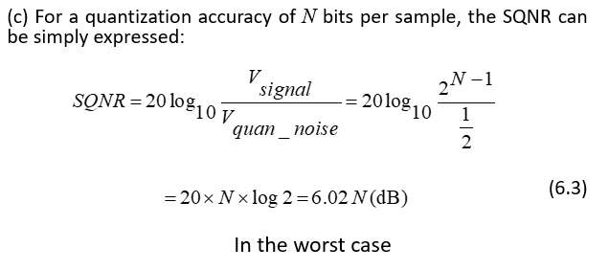

**(b) What do you mean by MIDI message? Discuss different type of MIDI message. 3.75**

**Ans:**

**Definition of MIDI:** MIDI is a protocol that enables computer, synthesizers, keyboards, and other musical device to communicate with each other.

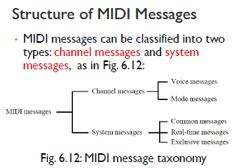

**Different type of MIDI message:**

1. **Channel messages: can have up to 3 bytes:**

* The first byte is the status byte (the opcode, as it were); has its most significant bit set to 1.
* The 4 low-order bits identify which channel this message belongs to (for 16 possible channels).
* The 3 remaining bits hold the message. For a data byte, the most significant bit is set to 0.

**Voice messages:**

* This type of channel message controls a voice, i.e., sends information specifying which note to play or to turn off, and encodes key pressure.
* Voice messages are also used to specify controller effects such as sustain, vibrato, tremolo, and the pitch wheel.

**Channel mode messages:**

* Channel mode messages: special case of the Control Change message → opcode B (the message is &HBn, or 1011nnnn).
* However, a Channel Mode message has its first data byte in 121 through 127 (&H79–7F).

**2. System Messages:**

System messages have no channel number — commands that are not channel specific, such as timing signals for synchronization, positioning information in pre-recorded MIDI sequences, and detailed setup information for the destination device.

**System common messages:** relate to timing or positioning.

**System real-time messages:** related to synchronization.

**System exclusive message:** included so that the MIDI standard can be extended by manufacturers.

**© An analog signal containing components with frequency values ranging from 60 Hz to 6 KHz is to be sampled. Determine the sampling frequency and the bandwidth of the band-limiting filter. If the signal is transmitted over a communication channel with a bandwidth from 100 Hz to 5 KHz, determine the sampling frequency and the bandwidth of the band-limiting filter. 2.5**

**Question No: 03**

**(a) Define luminance(Y) and chrominance(C) of a color signal. Explain the problems in transmitting color signal. 2.75**

**Ans:**

**Chrominance(C):**

Chrominance (*chroma* ) is the signal used in video systems to convey the color information of the picture, separately from the accompanying luma signal (or Y).

**Luminance(Y):**

RGB can be converted to a luminance (brightness signal) and two color difference signals (chrominance) for TV signal transmission.

**Problems in transmitting color signal:**

The problem is accentuated by the need to fit this color signal into a standard TV channel which is almost fully occupied by the ‘Y’ signal. However, to satisfy compatibility requirements the problem has been ingeniously solved by combining the color information into a single variable and by employing what is known as frequency interleaving.

**(b) Briefly discuss about Chroma sub-sampling on video signal transmission. 3**

**Ans:**

**Chroma sub-sampling:**

* Since human see color with much less spatial resolution than black and white, it makes sense to decimate the chrominance signal.
* Here label numbers are given stating how many pixel values, per four original pixels, are actually sent.
* Chroma subsampling scheme “4:4:4” indicates that no chroma subsampling is used.

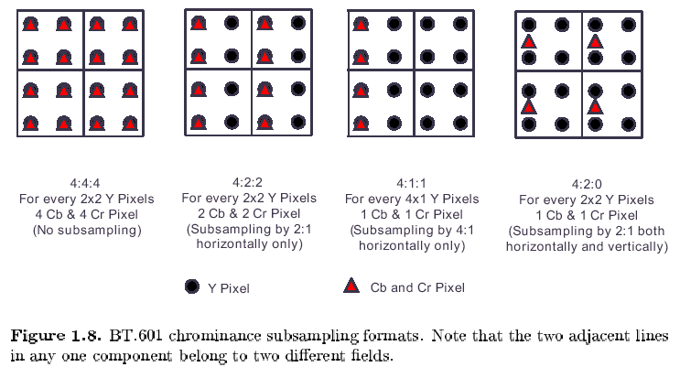

**© A PAL encoded video clip has a frame size 720*480 pixels and is digitized using s bit-depth of 8 bits for each of Y, Cb and Cr and a chroma sub-sampling scheme of 4:2:2, Calculate the file size of 1 minute of the video clip and the total time taken for it to be transmitted over s 2 Mbps transmission line. 3**

**Question No: 04**

**(a) Briefly discuss about the major steps involved in JPEG encoding. 4.5**

**Ans:**

**JPEG Encoding:**

* "Joint Photographic Expert Group". Voted as international standard in 1992.
* Works with color and grayscale images, e.g., satellite, medical, ...

**Motivation:**

The *compression ratio* of lossless methods (e.g., Huffman, Arithmetic, LZW) is not high enough for image and video compression.

JPEG uses *transform coding*, it is largely based on the following observations:

Observation 1: A large majority of useful image contents change relatively slowly across images, i.e., it is unusual for intensity values to alter up and down several times in a small area. Translate this into the spatial frequency domain, it says that, generally, lower spatial frequency components contain more information than the high frequency components which often correspond to less useful details and noises.

Observation 2: Humans are more receptive to the loss of higher spatial frequency components than the loss of lower frequency components.

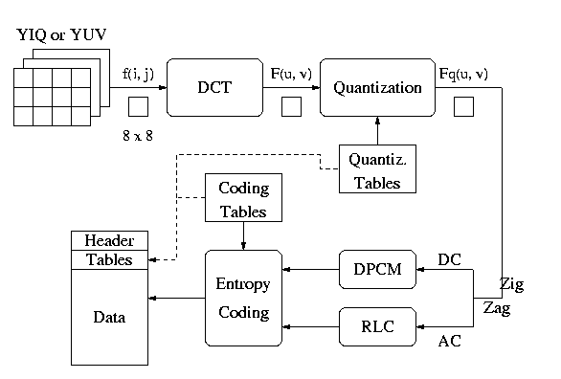

**(b) Use LZW algorithm to compress the string “ABABBABCABABBA” using the dictionary containing the following code –**

**Code String**

**1 A**

**2 B**

**3 C**

**Ans:**

• Let’s start with a very simple dictionary (also referred to as a “string table”), initially containing only 3 characters, with codes as follows:

Code String

1 A

2 B

3 C

• Now if the input string is “ABABBABCABABBA”, the LZW compression algorithm works as follows:

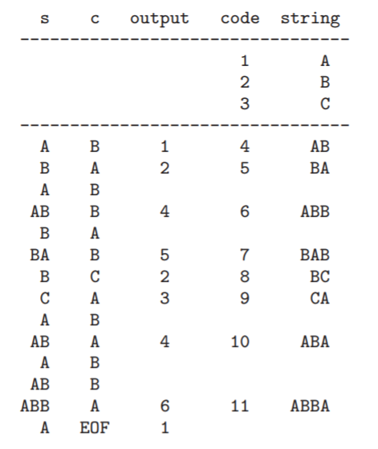

The output codes are: 1 2 4 5 2 3 4 6 1. Instead of sending 14 characters, only 9 codes need to be sent (compression ratio = 14/9 = 1.56).

**Decompression of LZW:**

